**WEB DEVELOPMENT INTERNSHIP PROJECT 3**

**Name**: Pratik Pawar

**Project Title:** E-commerce product page

**Internship Name:** Web Development Internship

**Submission Date:** 05/02/2025

**Email:** pratikpawar7225@gmail.com

**Phone number:** 9552524565

**Table of Contents**

1. Introduction
2. Objective
3. Project Details
4. Features Implemented
5. Challenges and Learnings
6. Responsive Design and Testing
7. Code Snippets
8. Screenshots
9. Conclusion

**Introduction**

The **E-commerce Product Page** is a user-friendly and visually appealing web page designed to enhance the online shopping experience. It displays essential product details such as the product image, name, description, price, and an "Add to Cart" button, all presented within a modern and clean layout. Additional sections like customer reviews and related products contribute to a seamless shopping journey for users.

**Objective**

The primary objective of this project is to:

* Develop a functional and responsive e-commerce product page.
* Implement a visually attractive layout with interactive UI elements.
* Ensure cross-device compatibility and an optimal user experience.
* Learn and demonstrate skills in HTML, CSS, and JavaScript.

**Project Details**

• **Technologies Used:** HTML, CSS, JavaScript

• **Key Components:**

* Navigation bar with links to other sections.
* Product display section with an image slider.
* Product details including name, description, price, and an "Add to Cart" button.
* Customer reviews section.
* Related products grid.

**Features Implemented**

1. Product Image Slider: A functional slider to showcase multiple product images.
2. Add-to-Cart Button: A highlighted button with hover effects for easy user interaction.
3. Customer Reviews: Display reviews and ratings to build customer trust.
4. Related Products Section: Showcases similar products for upselling.
5. Responsive Design: Ensures the page adapts to various screen sizes and devices.
6. Modern UI Enhancements: Hover effects and smooth animations for buttons and images.

**Challenges and Learnings**

• Challenges:

* Creating a responsive design that works across all devices.
* Implementing a functional image slider with JavaScript.
* Ensuring smooth transitions and animations without affecting performance.

• Learnings:

* Mastered advanced CSS for layouts, hover effects, and responsiveness.
* Gained experience using JavaScript to add interactivity.
* Understood the importance of user-centered design for e-commerce.

**Screenshots.**

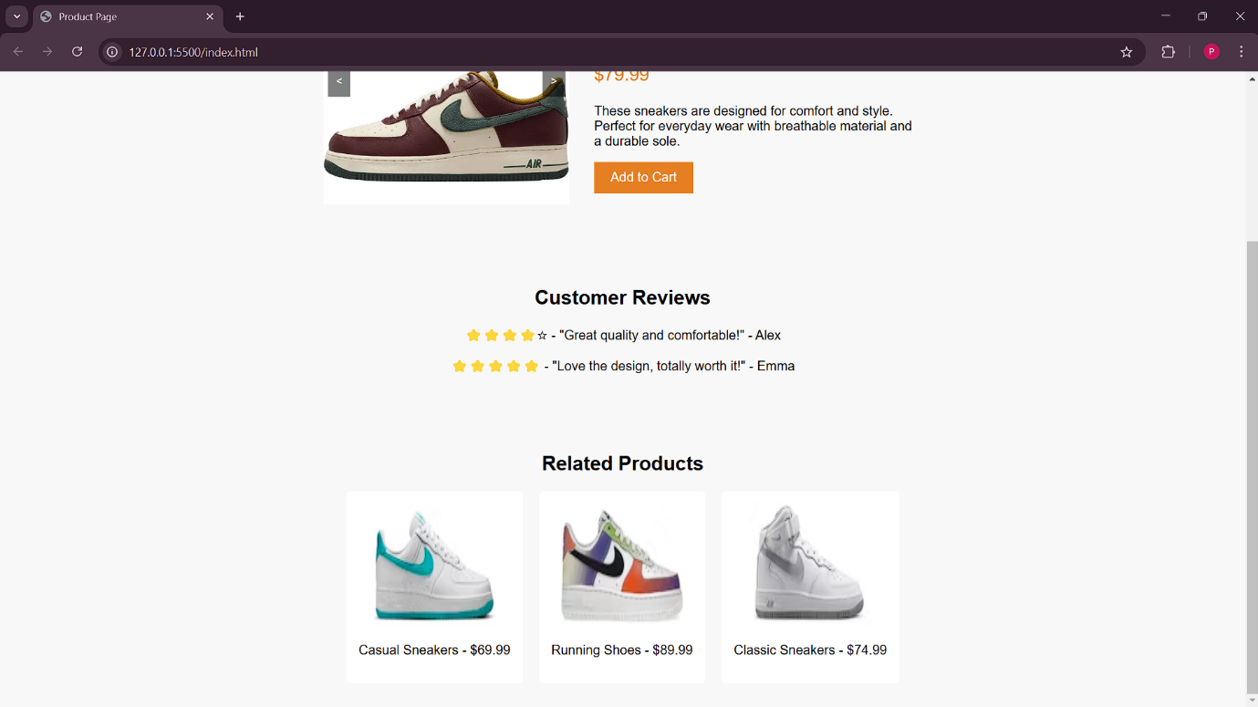

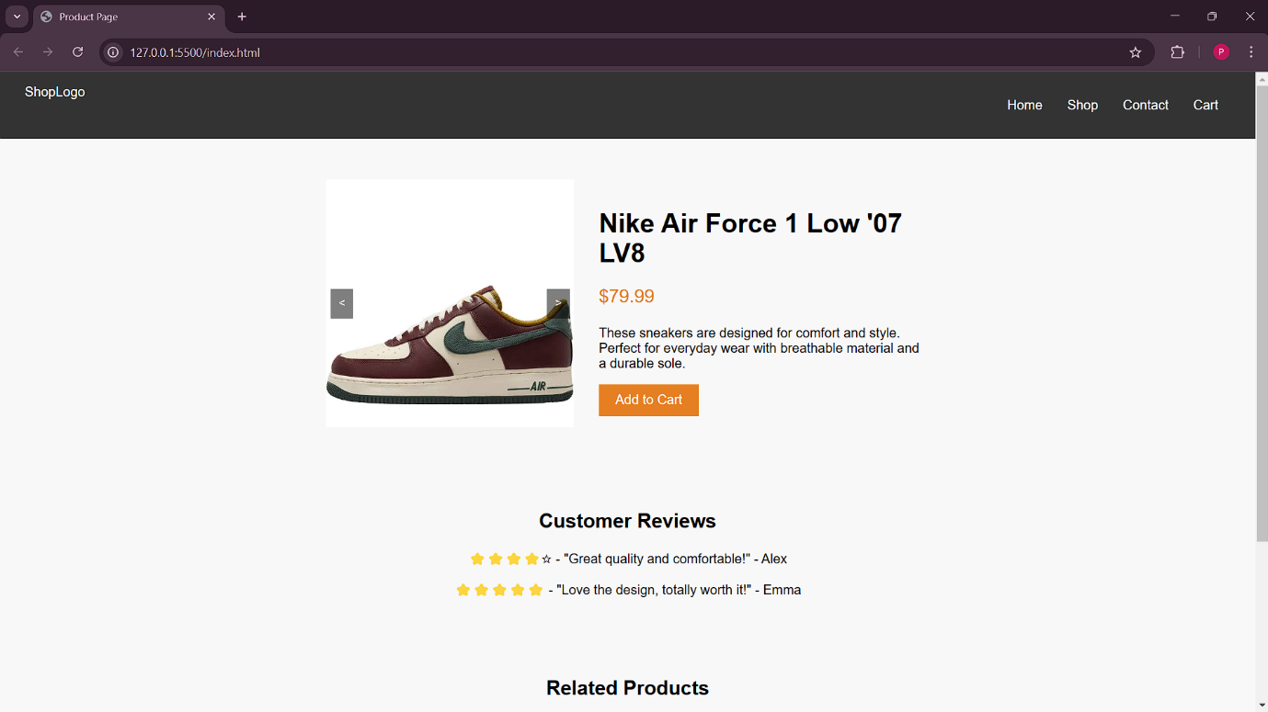

**Conclusion**

This project demonstrates the ability to design and implement a functional, visually appealing, and responsive e-commerce product page. The features implemented ensure a seamless shopping experience for users while maintaining good coding practices. This project was an excellent opportunity to practice web development skills and improve UI/UX design knowledge.